Fly Away Project Specification Document

Course : PG FSD PG FSD Become a back-end expert and part of PG FSD Caltech program

Programmer Details: Remya Pillai

Git Hub Link: <https://github.com/RemyaPillai99/FlyAway_TicketBookingWebsite>

**Project Details:**

FlyAway is an airline ticket-booking website.

## Website Flow

**Home page**

* displays options to Book Flight, Login for Customer and Admin.

**Book Flight** –

* Customer can login with existing credentials or sign up if desired
* Customer has option to book from site as guest without logging into website.
* To search for the available flights customer has to provide details such as (Source, Destination, Travel class, Date of travel and Number of passengers)
* Customer selects one of the flight from the search results to proceed with the booking.
* Customer enters all Passenger details that are travelling.
* Customer is sent to a dummy payment page.
* After successful payment customer is shown the booked confirmation details.
* Customer can continue shopping to book new flight or log out.
* Customer can change login password if desired

**Admin Login** -

* Admin can login into website with their credentials
* If the details provided are correct admin is sent to Admin Management Page
* In Admin Management page admin can see list of all the available flights
* Admin also has the option to Add/View/ Edit flight details
* Admin can also manage adding or viewing the Airports and Airline details.
* Admin can also change their password if desired.

## Technologies Used

**Frontend** - JSP, HTML, CSS, Bootstrap4, jQuery  
**Backend** - JAVA Servlets, Hibernate, Maven   
**Database** - MySQL  
**Application Server** - Tomcat v8.5

1. **Home Page of FlyAway Website: Include options for Booking Flight and Login(for customer and admin)** 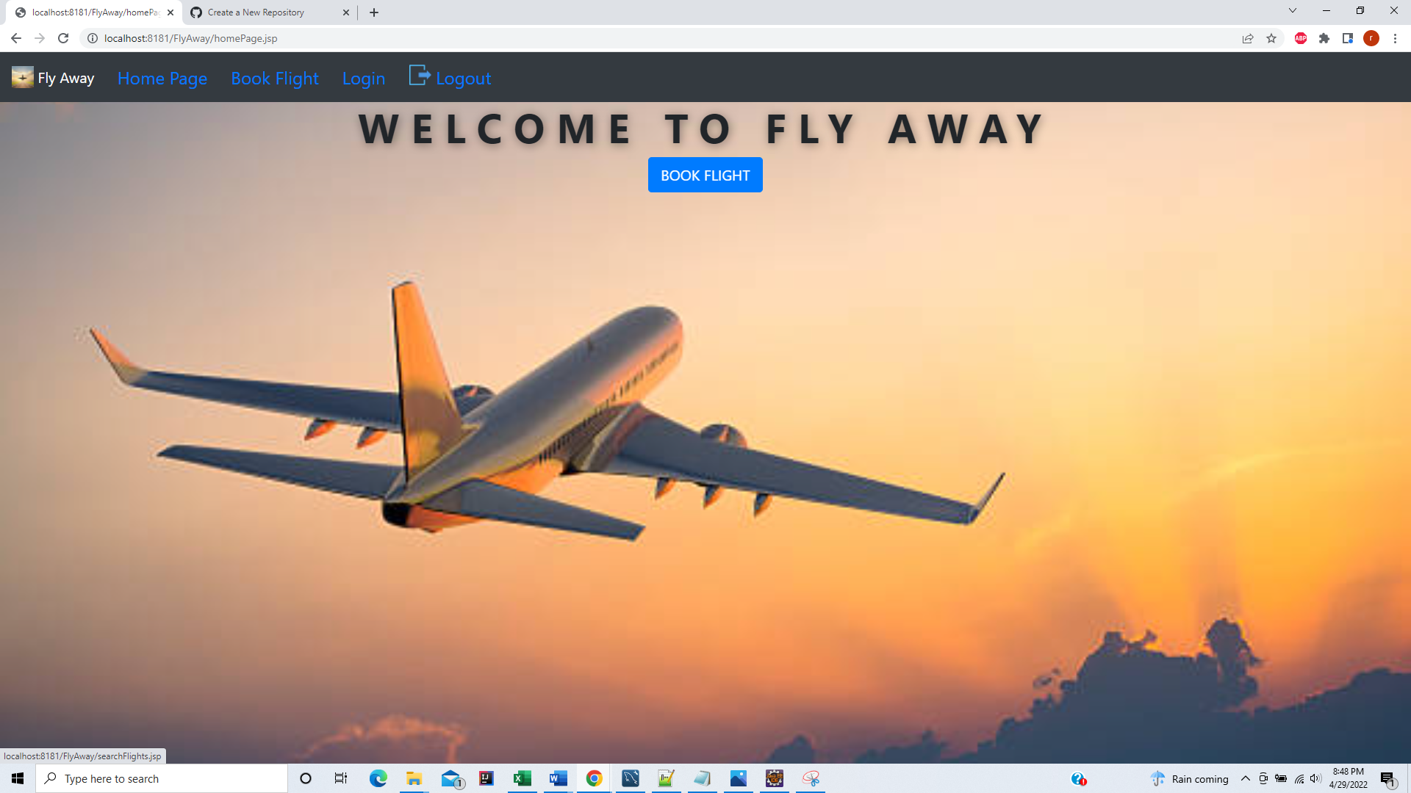

2. When user clicks on Book Flight – Search flight form shown

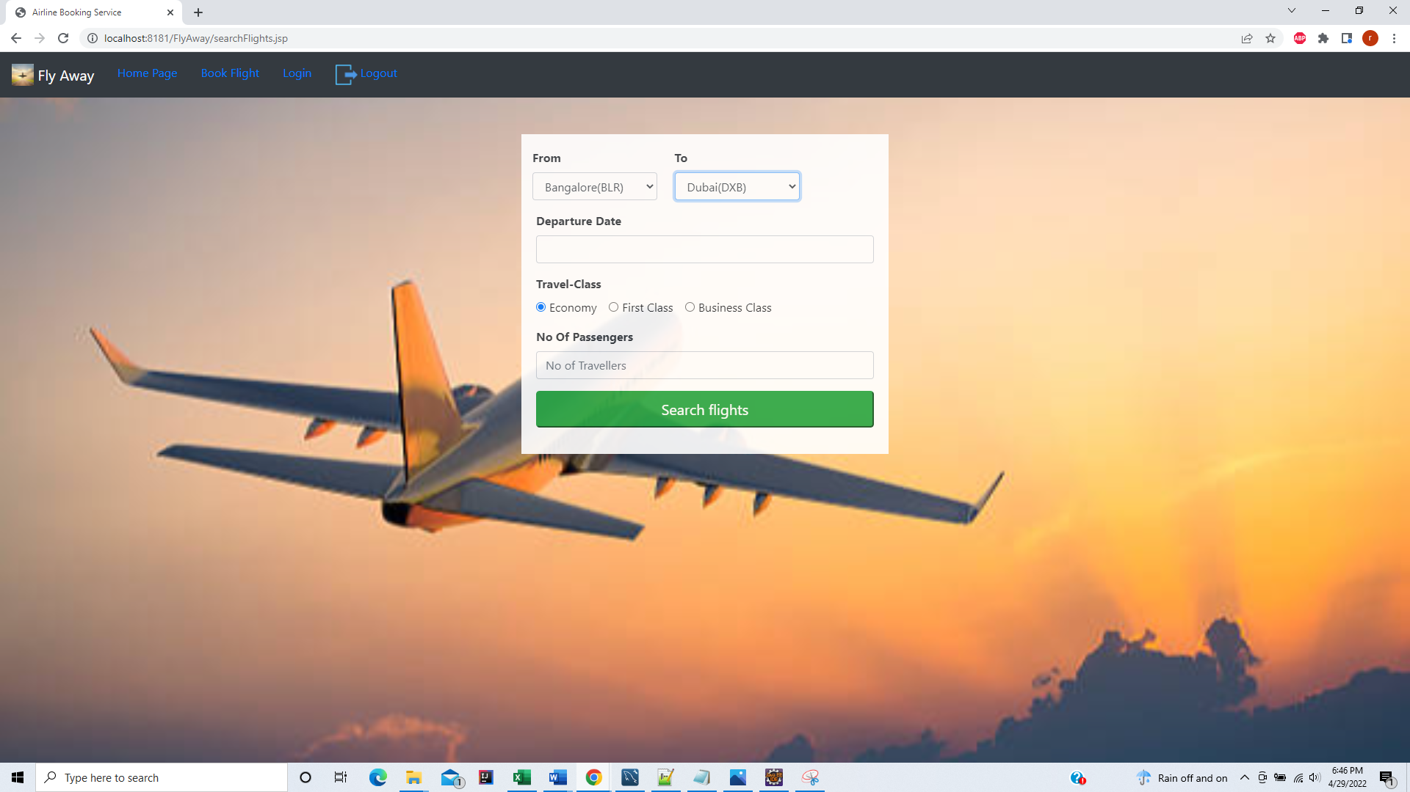

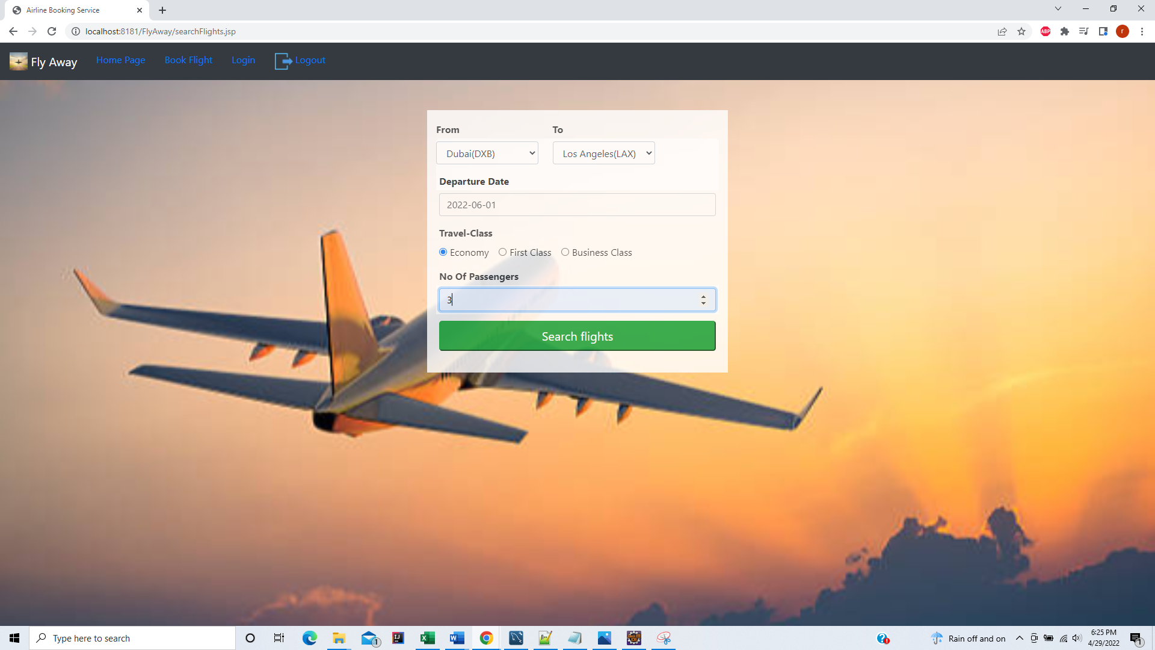

If flights are available from the provided criteria, Customer will be directed to Flight details page where they will see all the flights available for the provided criteria. Seats Available – Calculated .

Customer can click on corresponding flight book flight button that he wants to continue booking with.

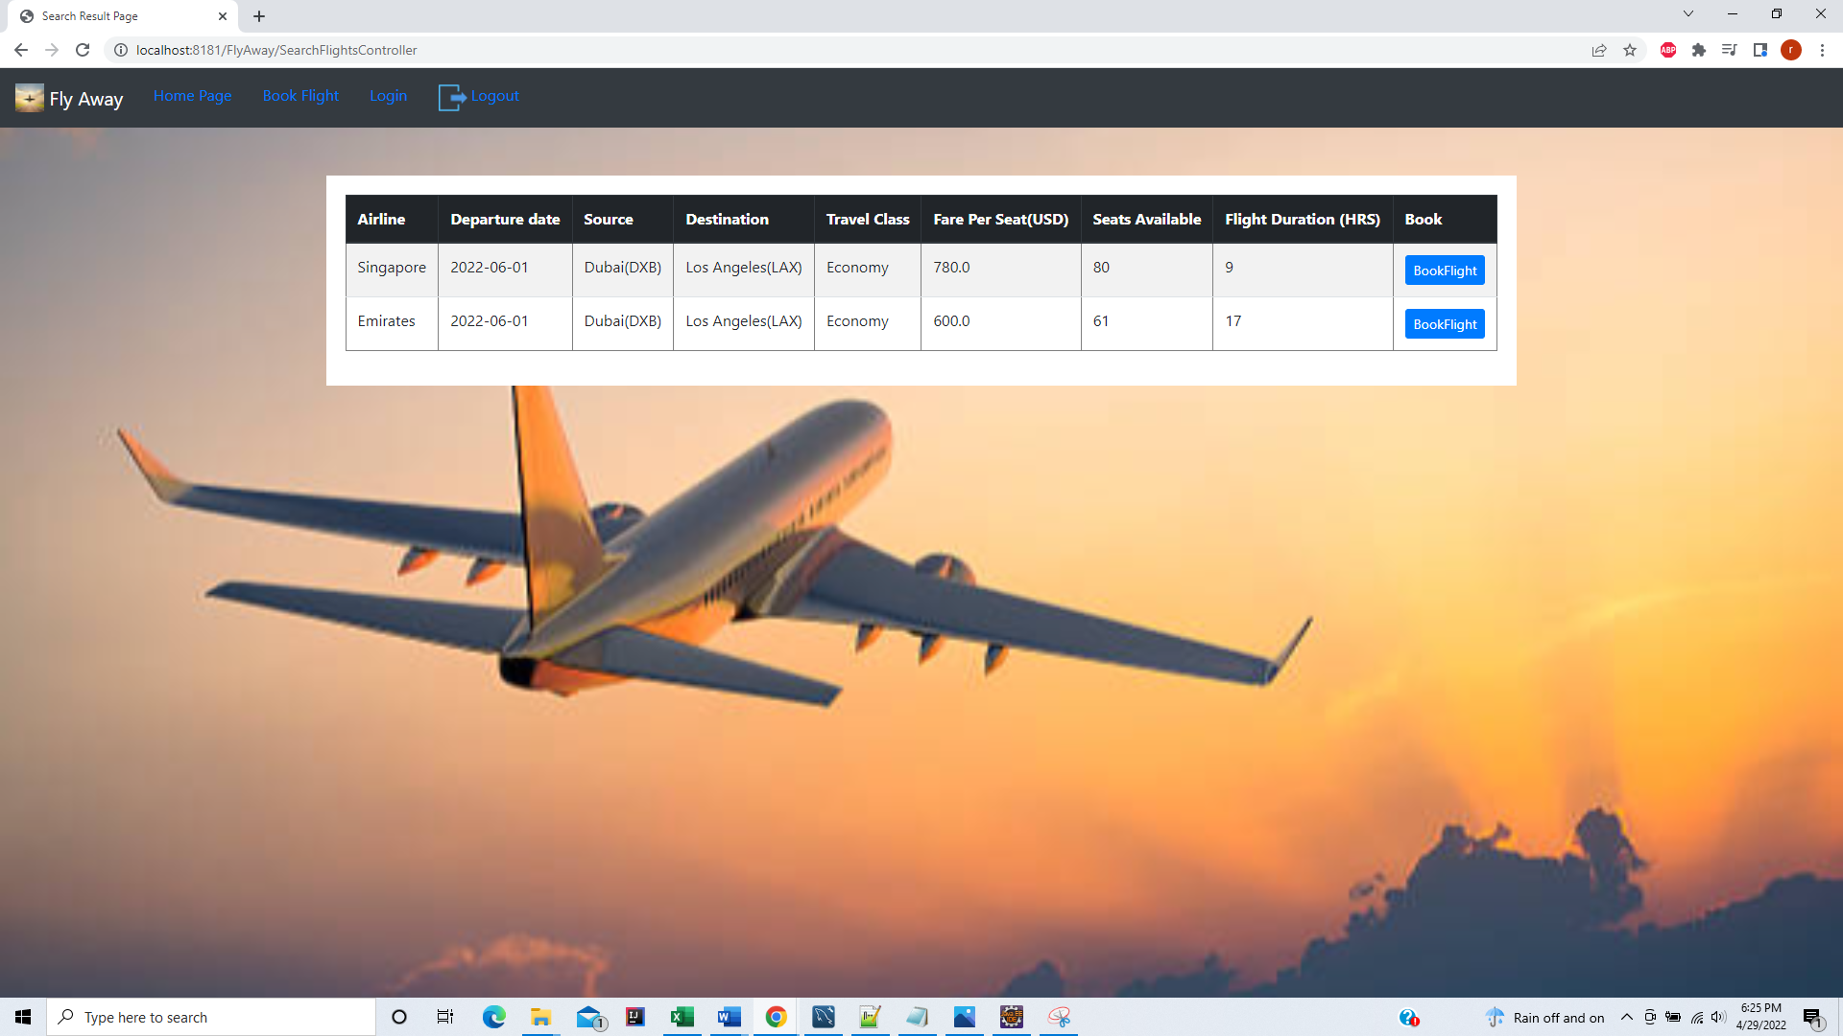

Confirming from values in flight Table that the search result correct.

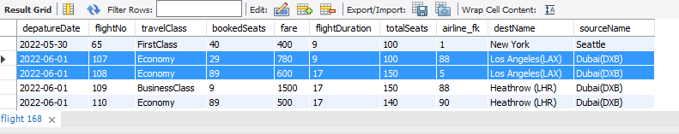

Passenger Registration Forms: Enter details for all passengers.

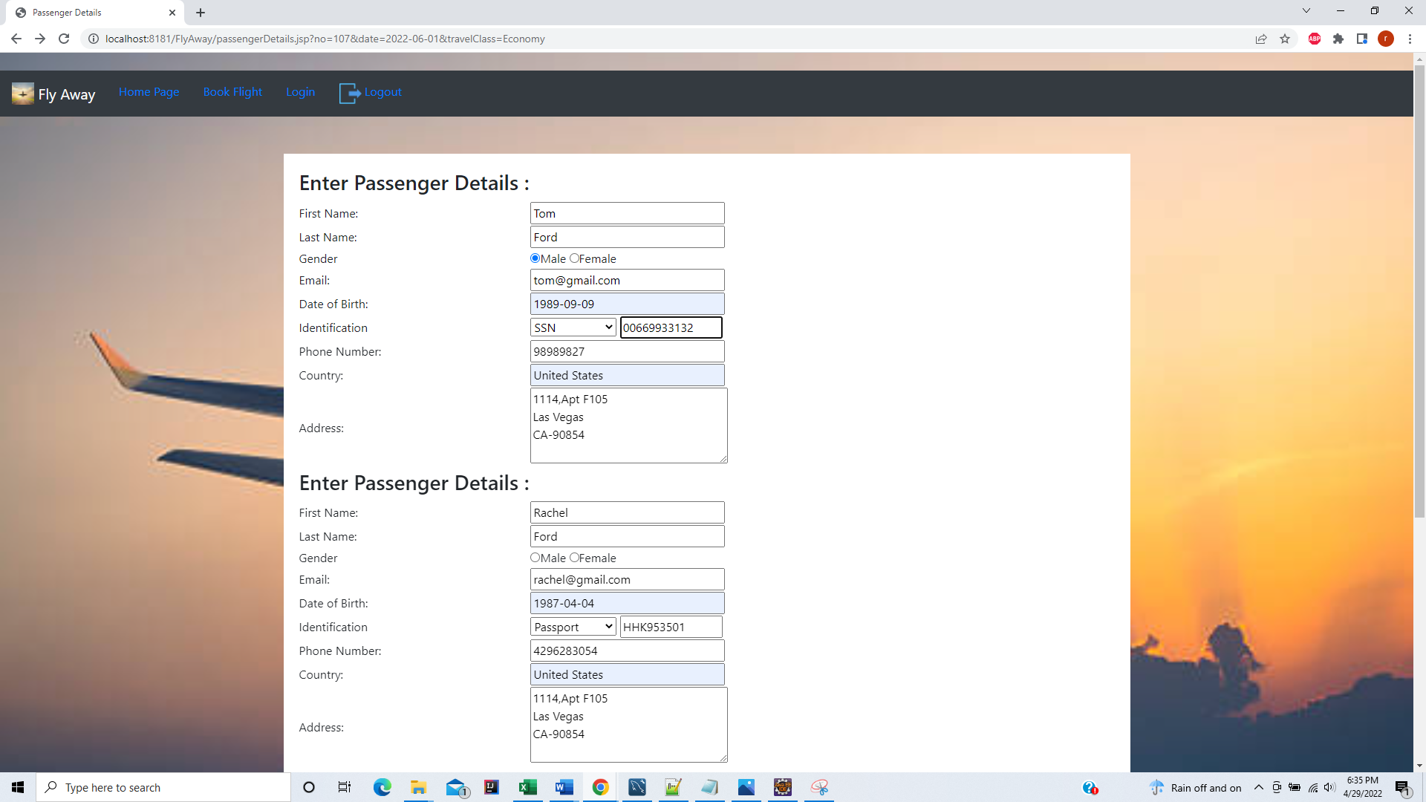

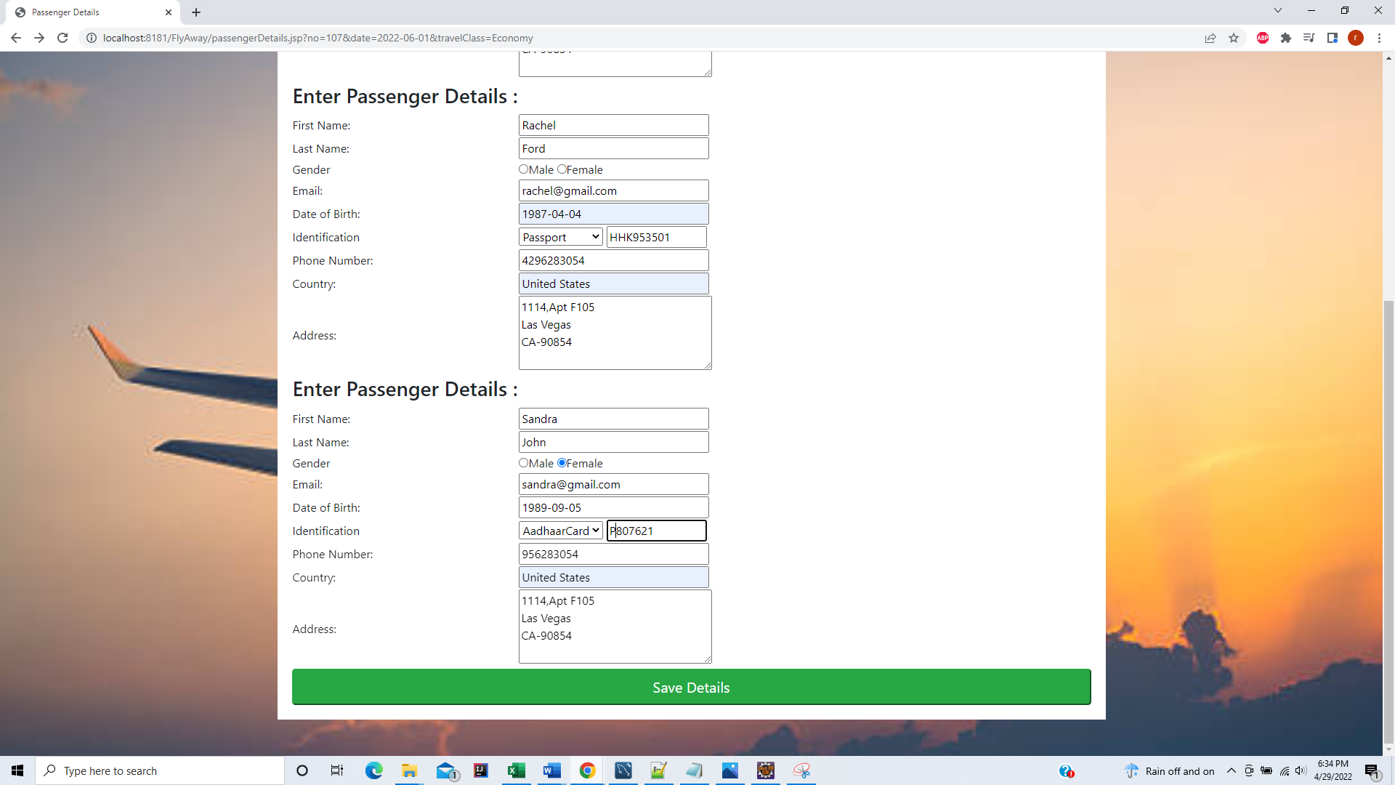

Save the Passenger Details in Database

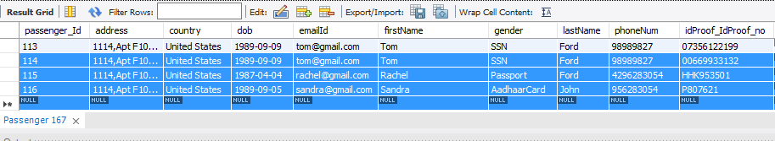

Payment details Page

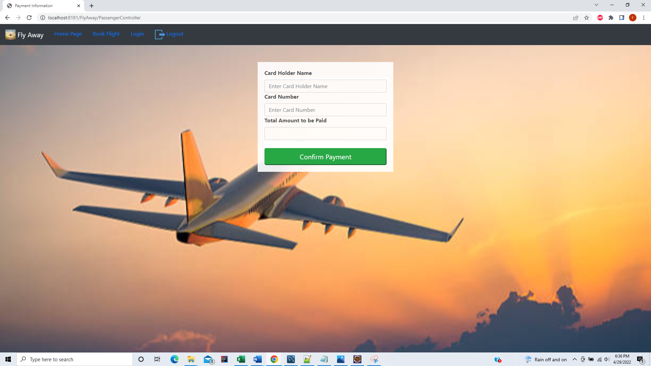

Once Payment successful – Display Booking Confirmation with all details.

User can go back to Booking more Flights by clicking on Continue shopping

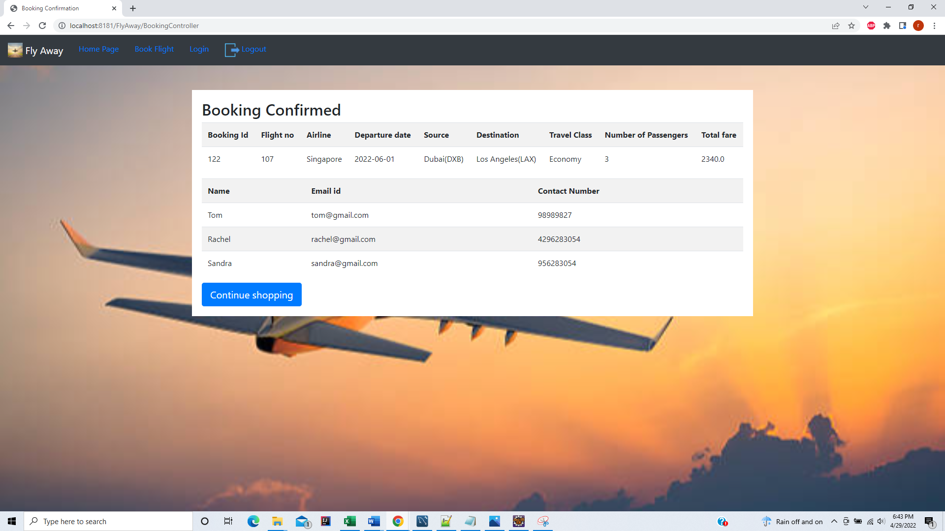

Data stored in BookingDetail table with corresponding Booking id Passenger Id and Flight Id

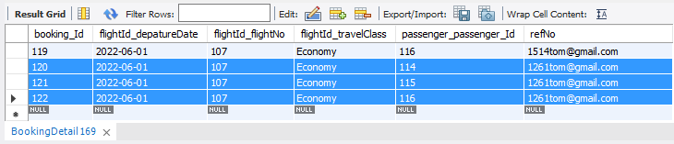

Corresponding flight

If the user enters criteria which has no flights – then valid message is displayed

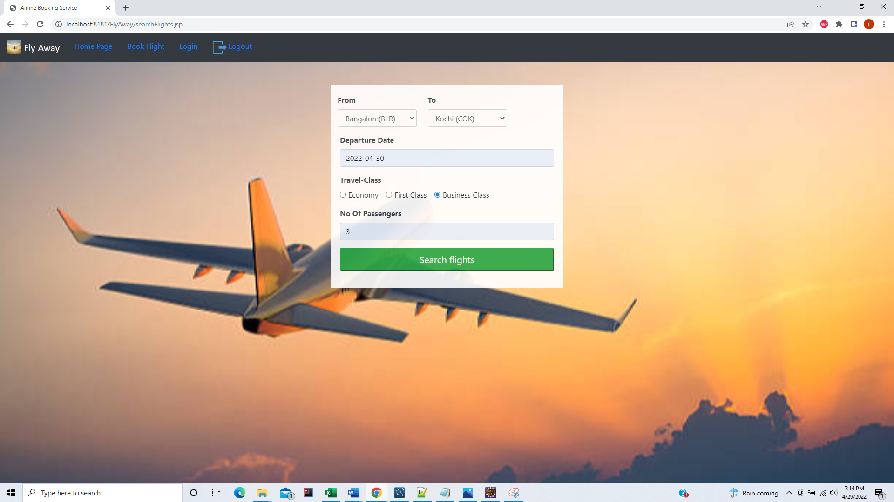

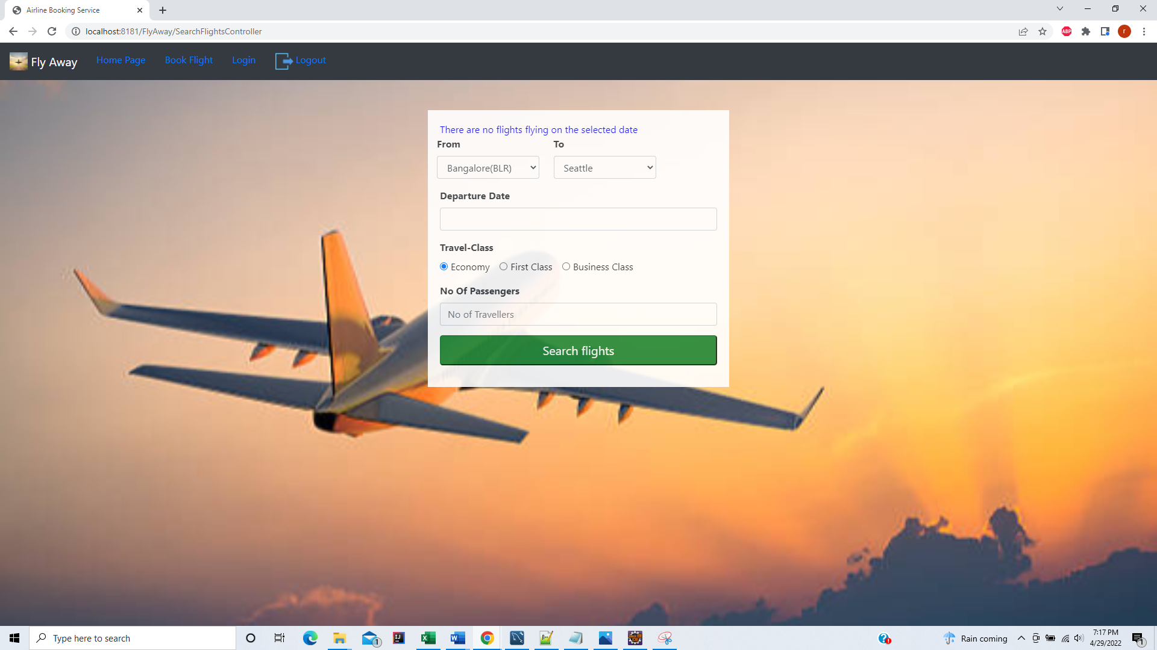

**ADMIN user role related flow:**

If credentials entered are of admin then corresponding Admin details page is shown:

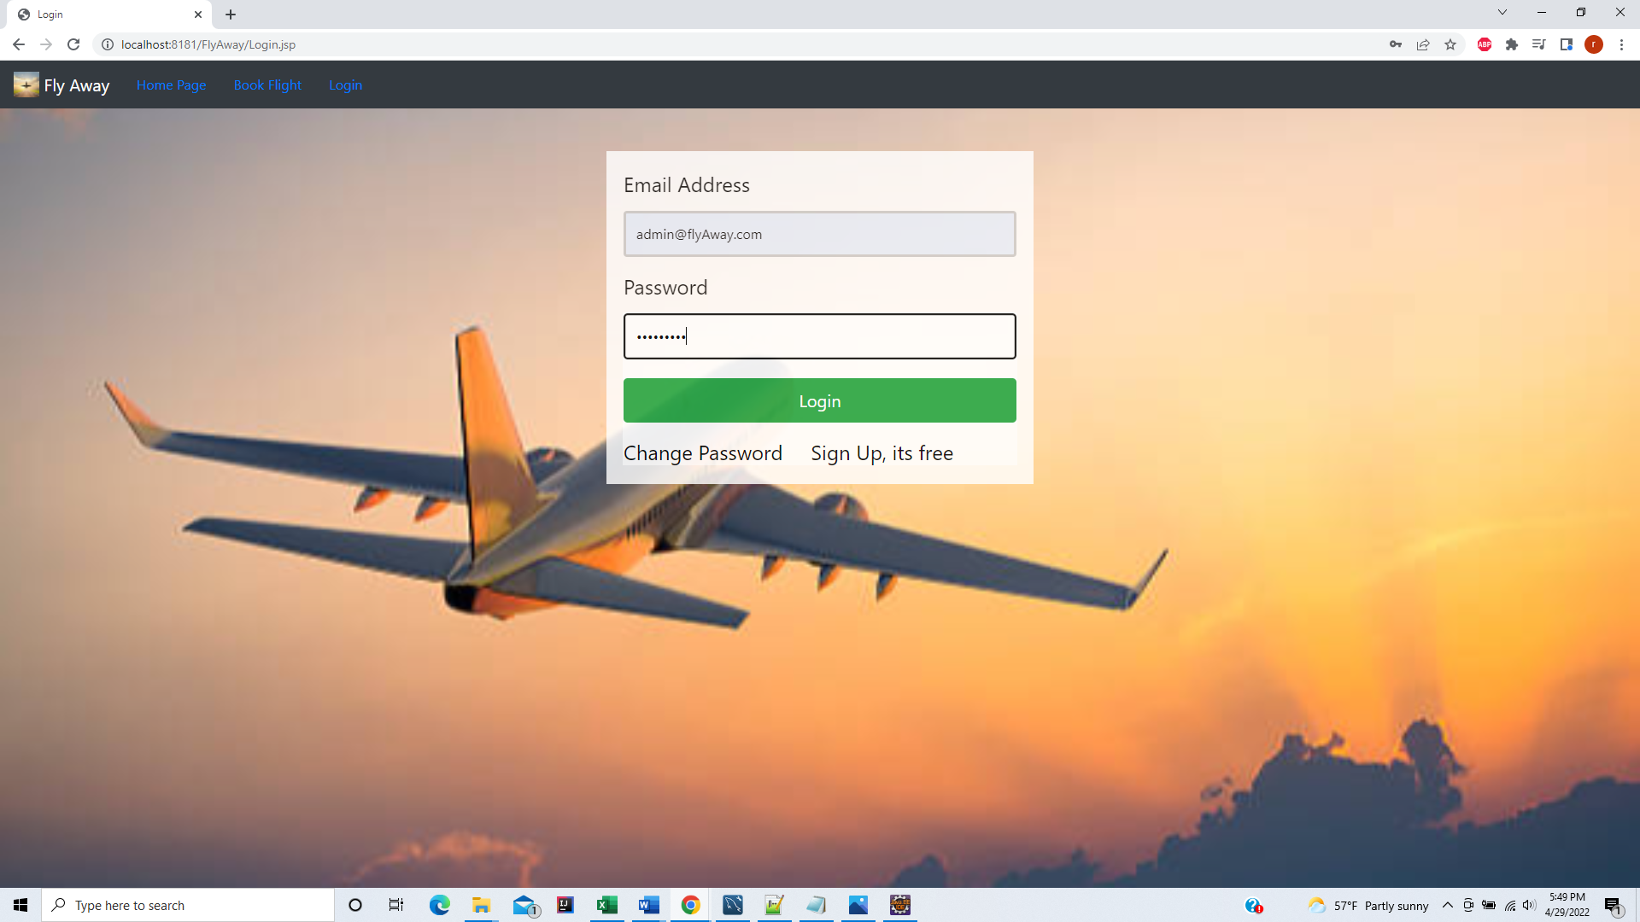

Admin Details Page: Admin have options to Add /View /Edit Flight details ,Airline and Airport location

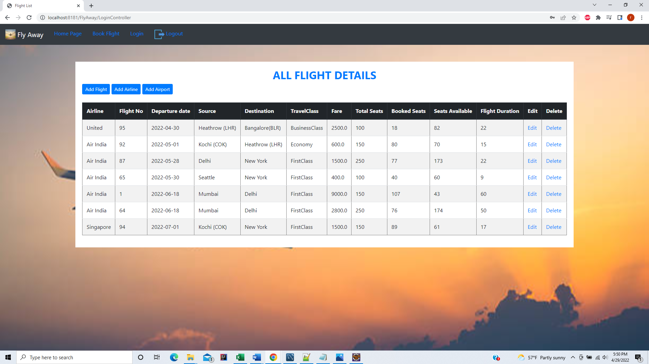

Add /View Airport locations

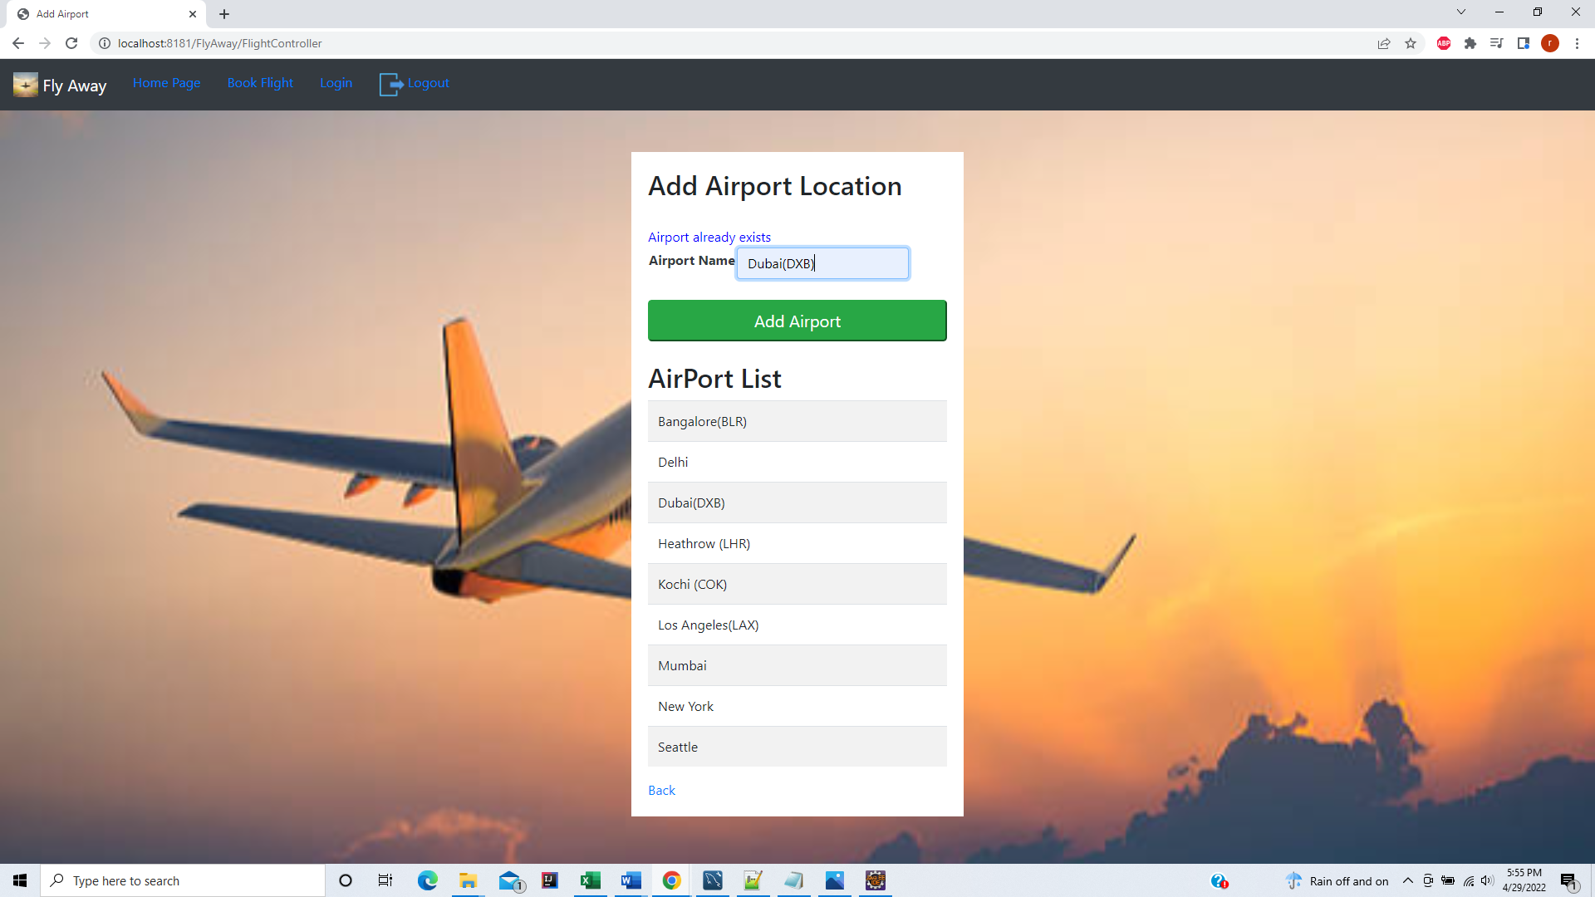

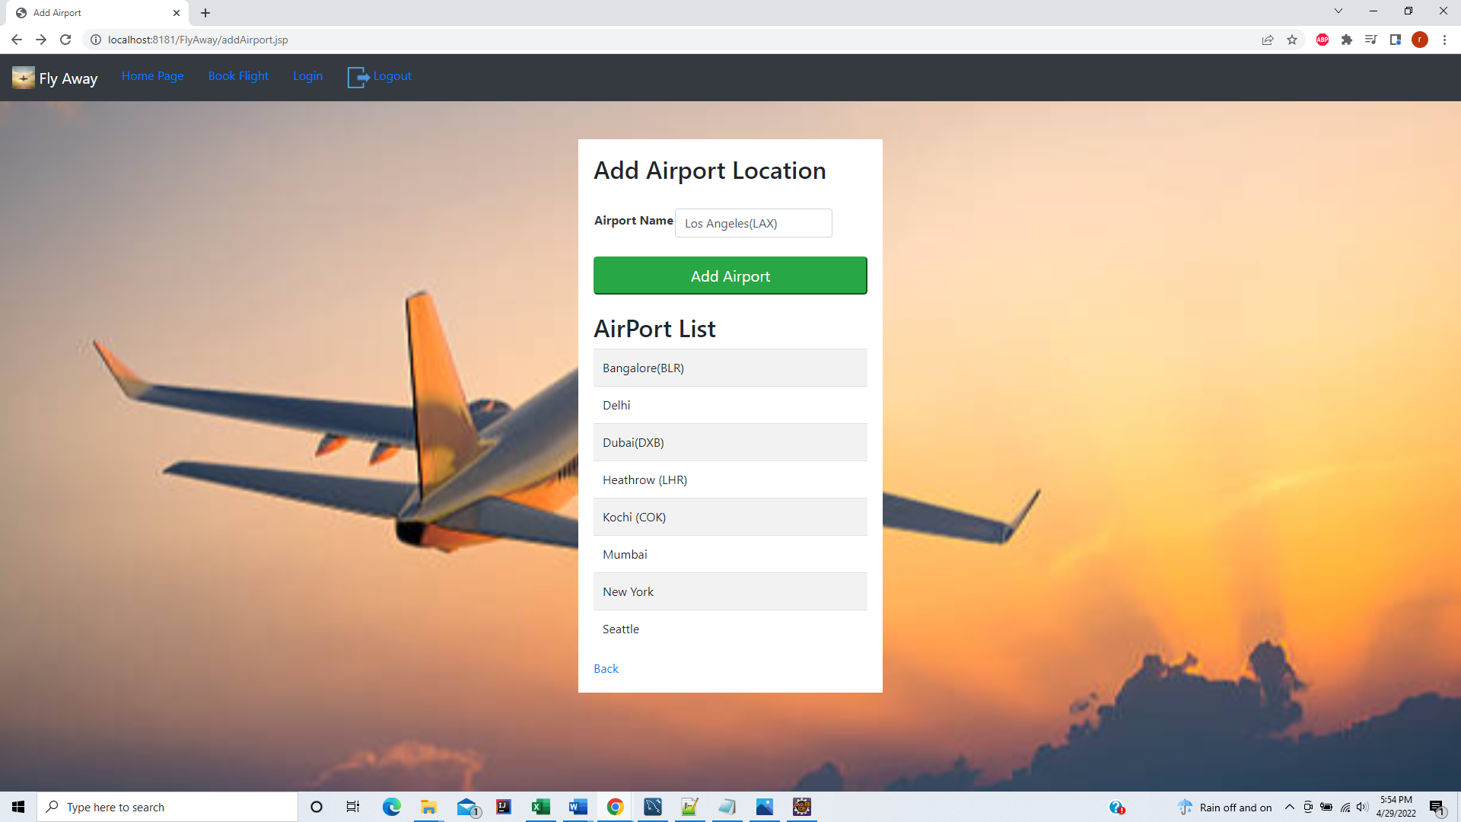

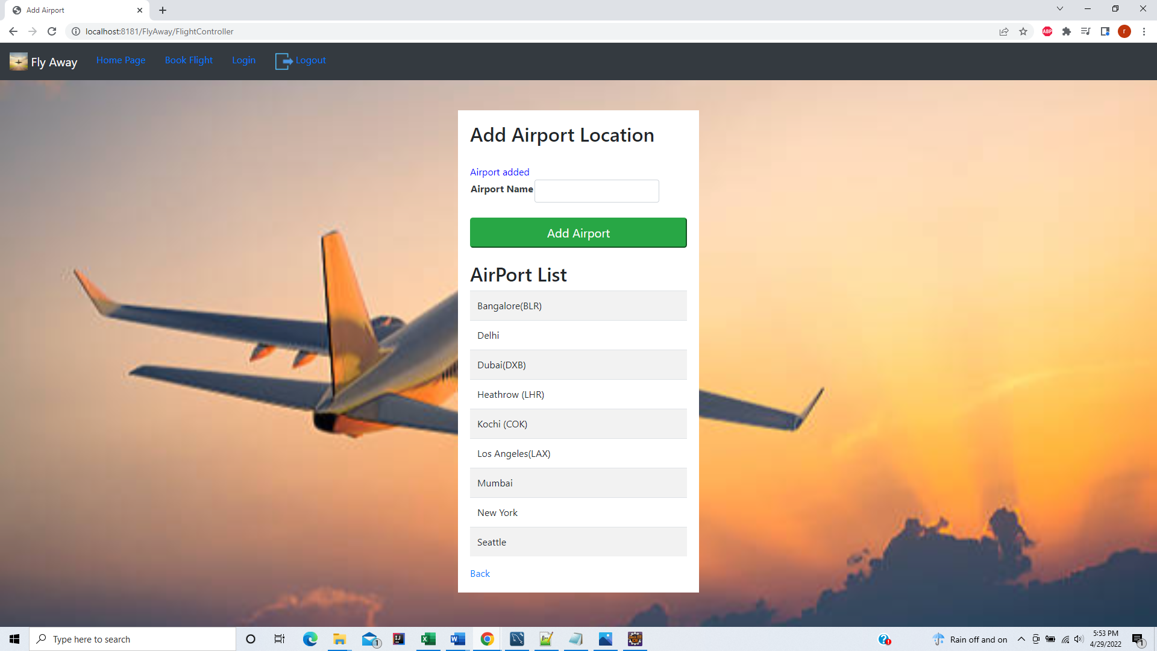

Add /View Airline List

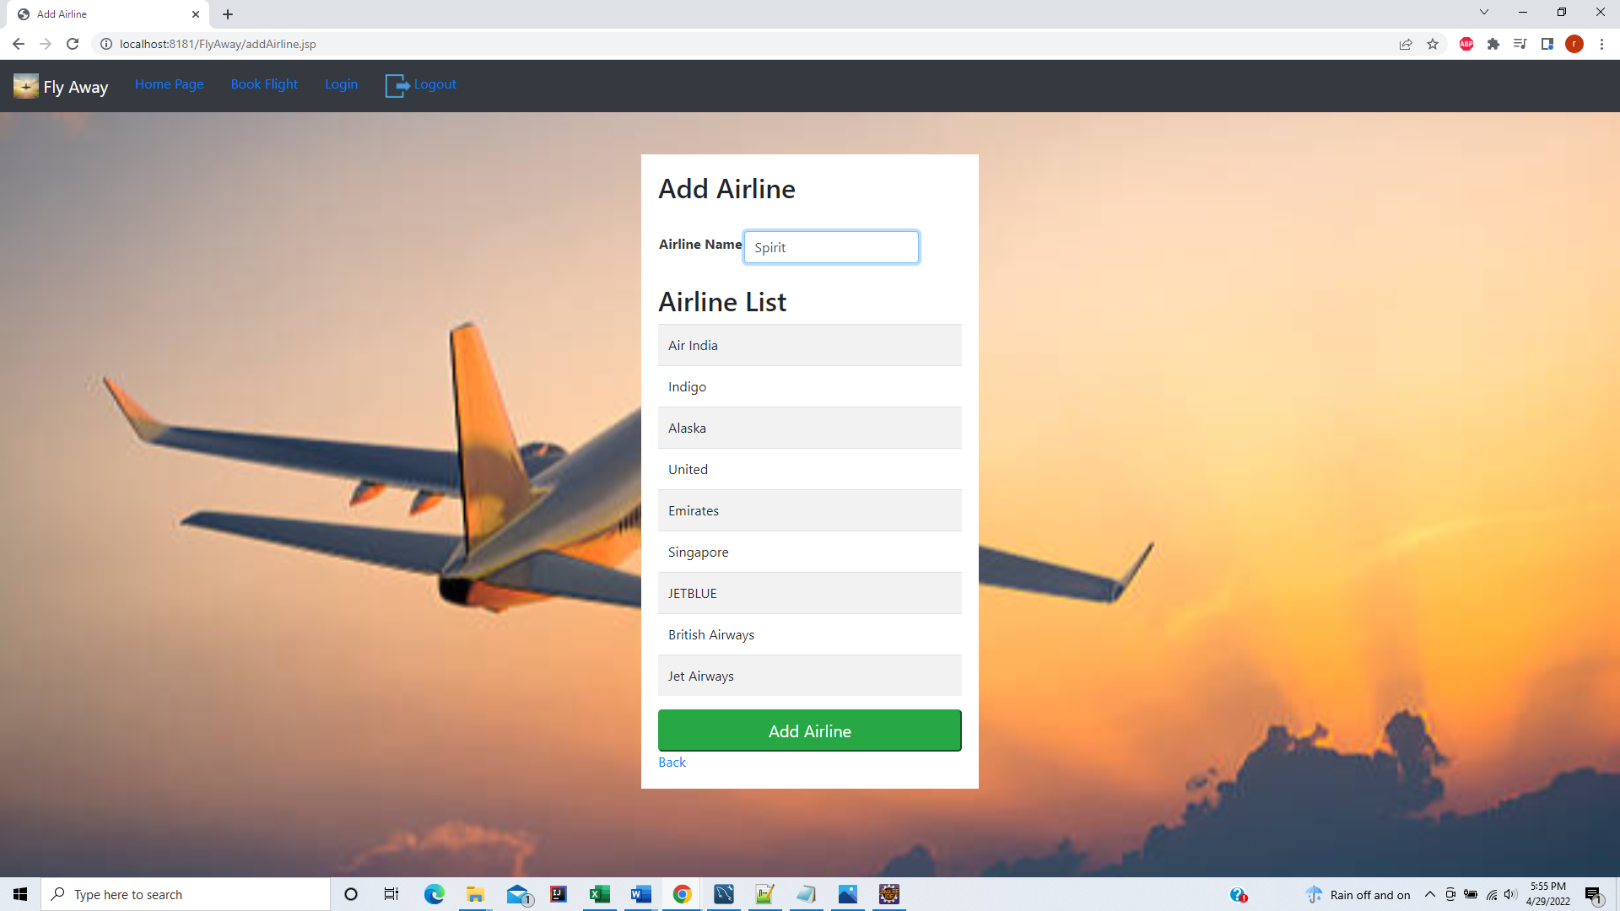

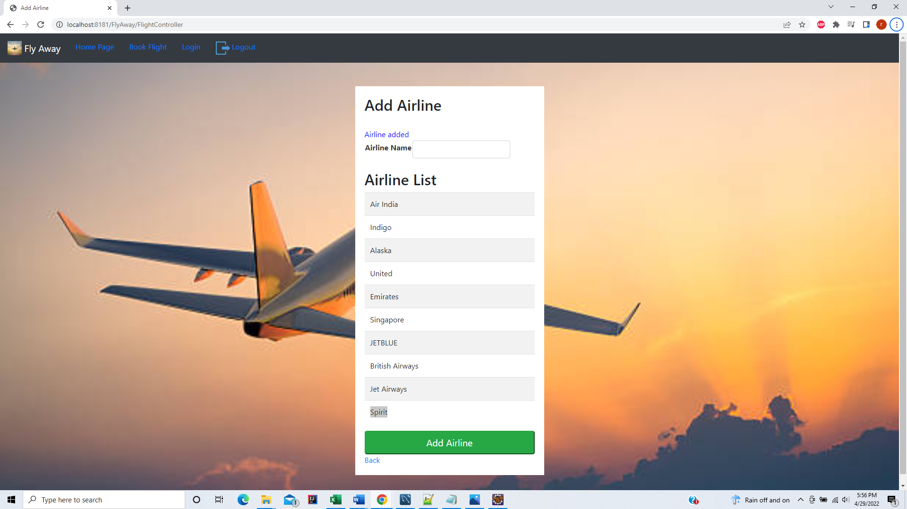

Add new Flight details

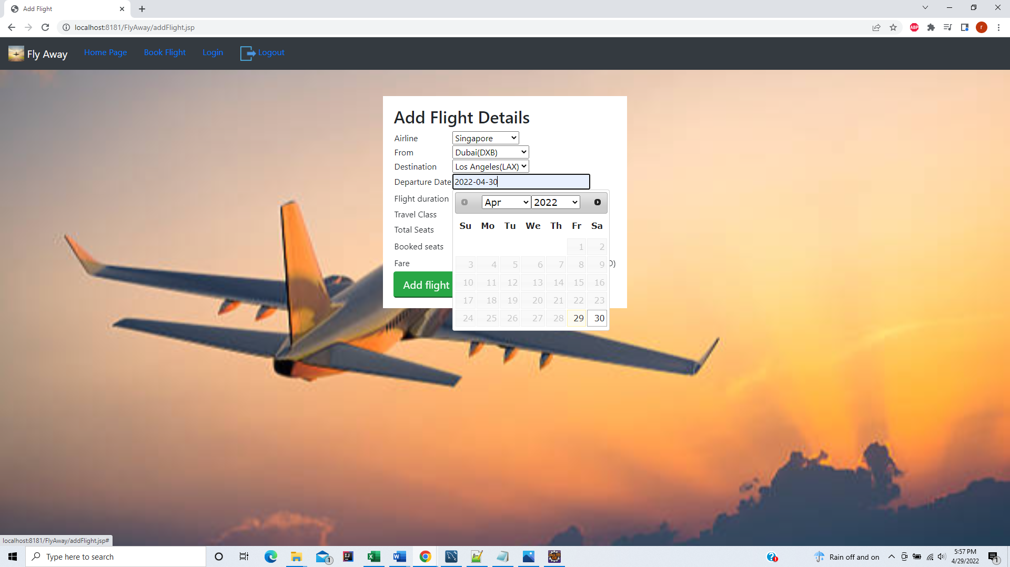

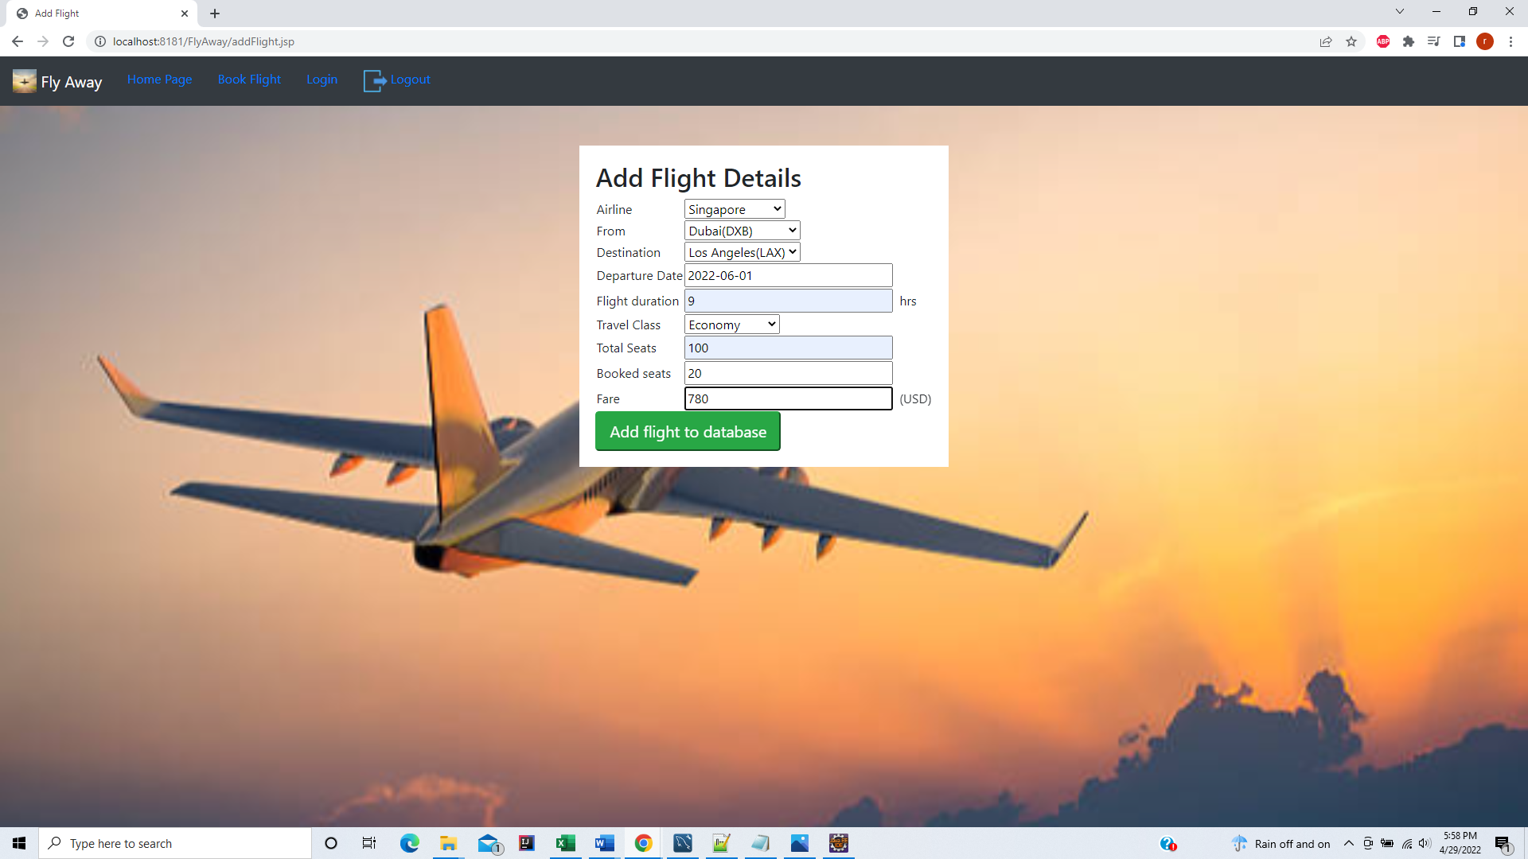

Confirmed added flight details in database

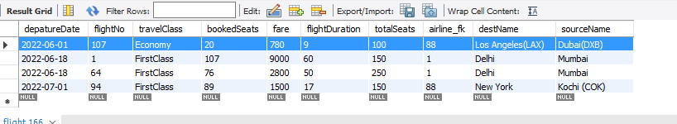

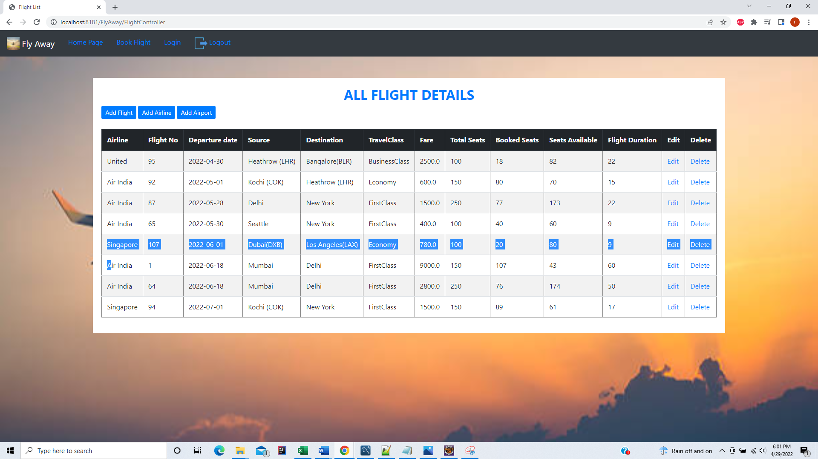

On Clicking Edit on corresponding flight detail – Edit Flight Form displayed

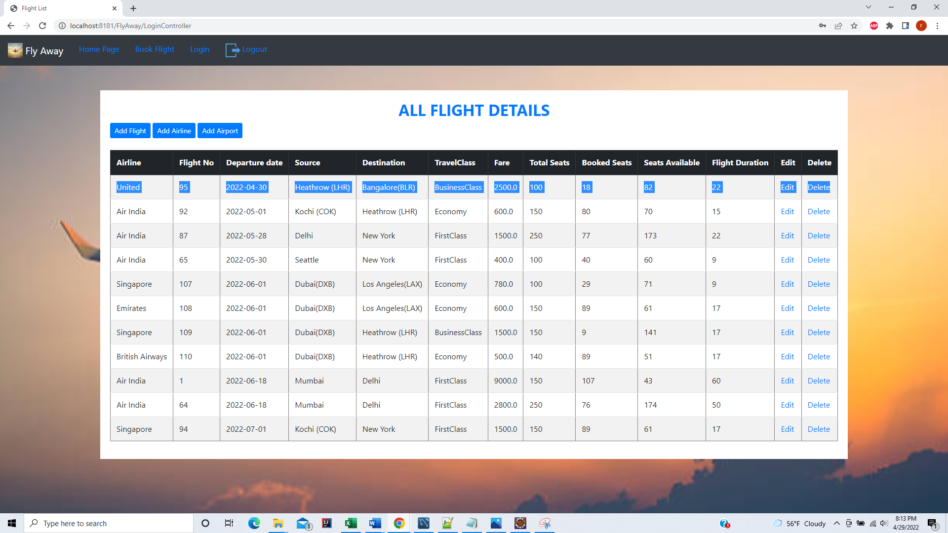

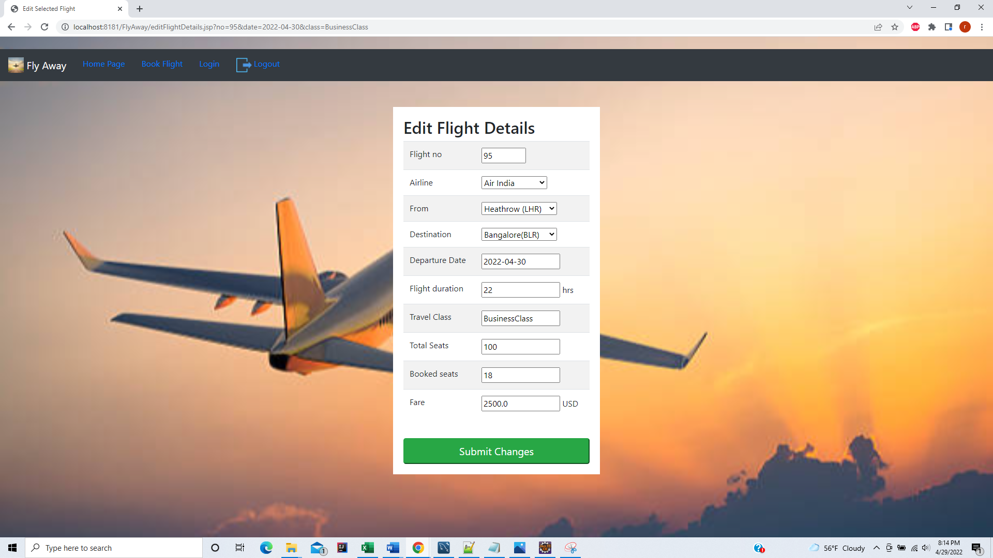

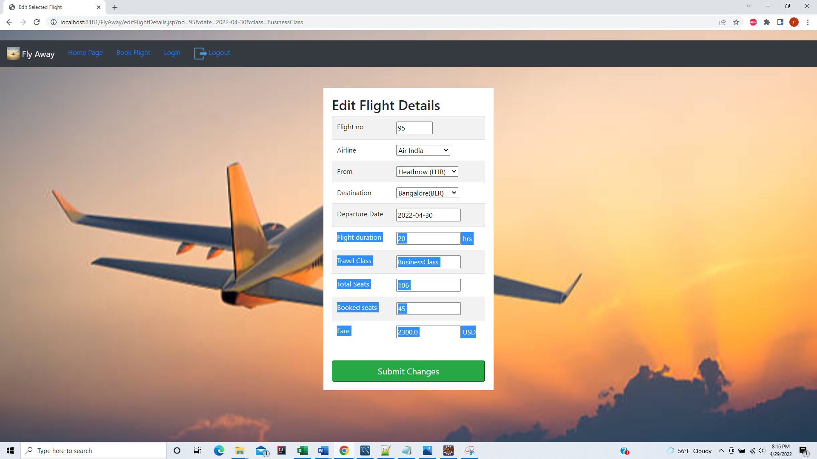

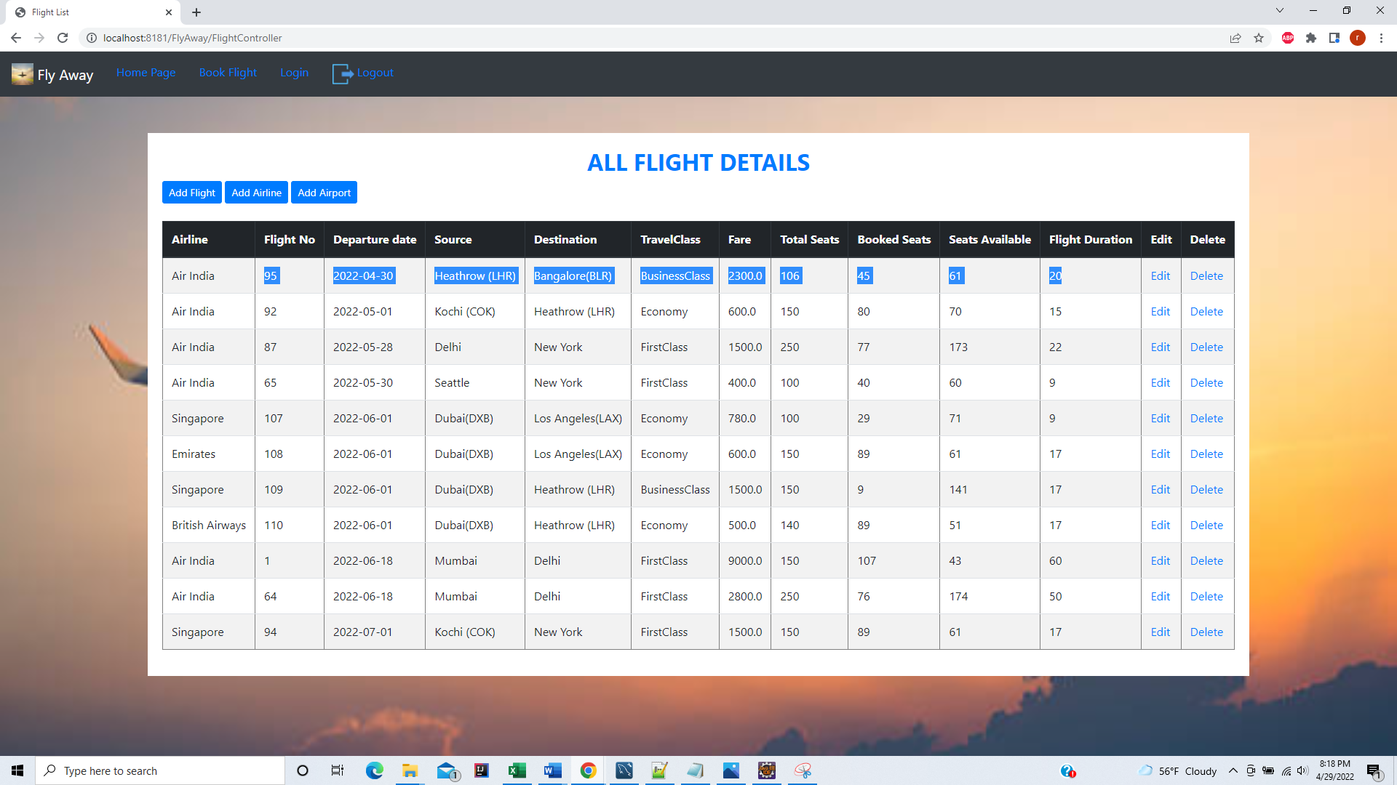

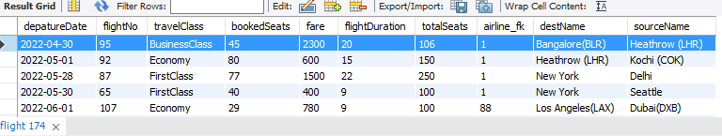

On clicking delete

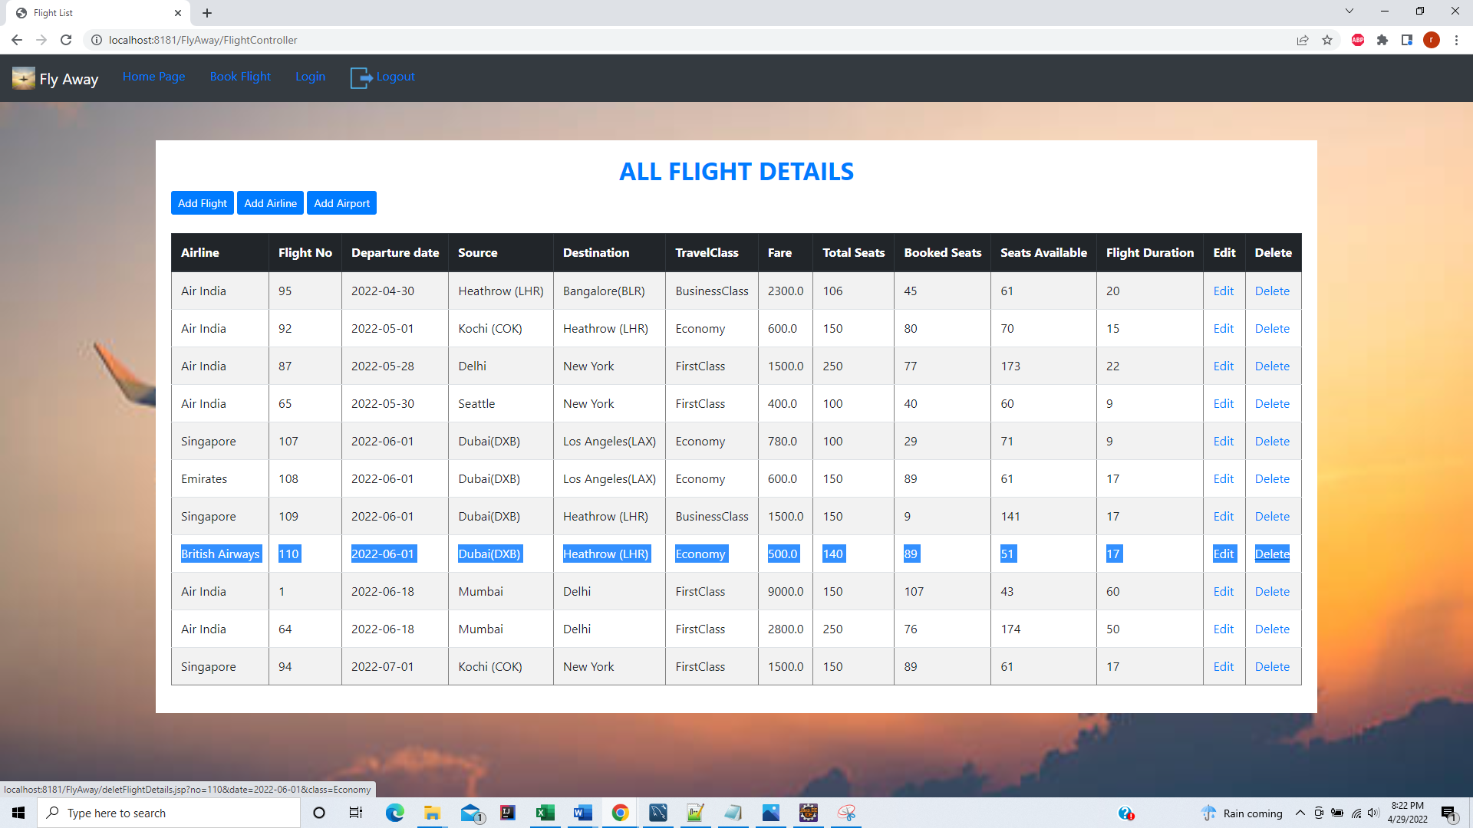

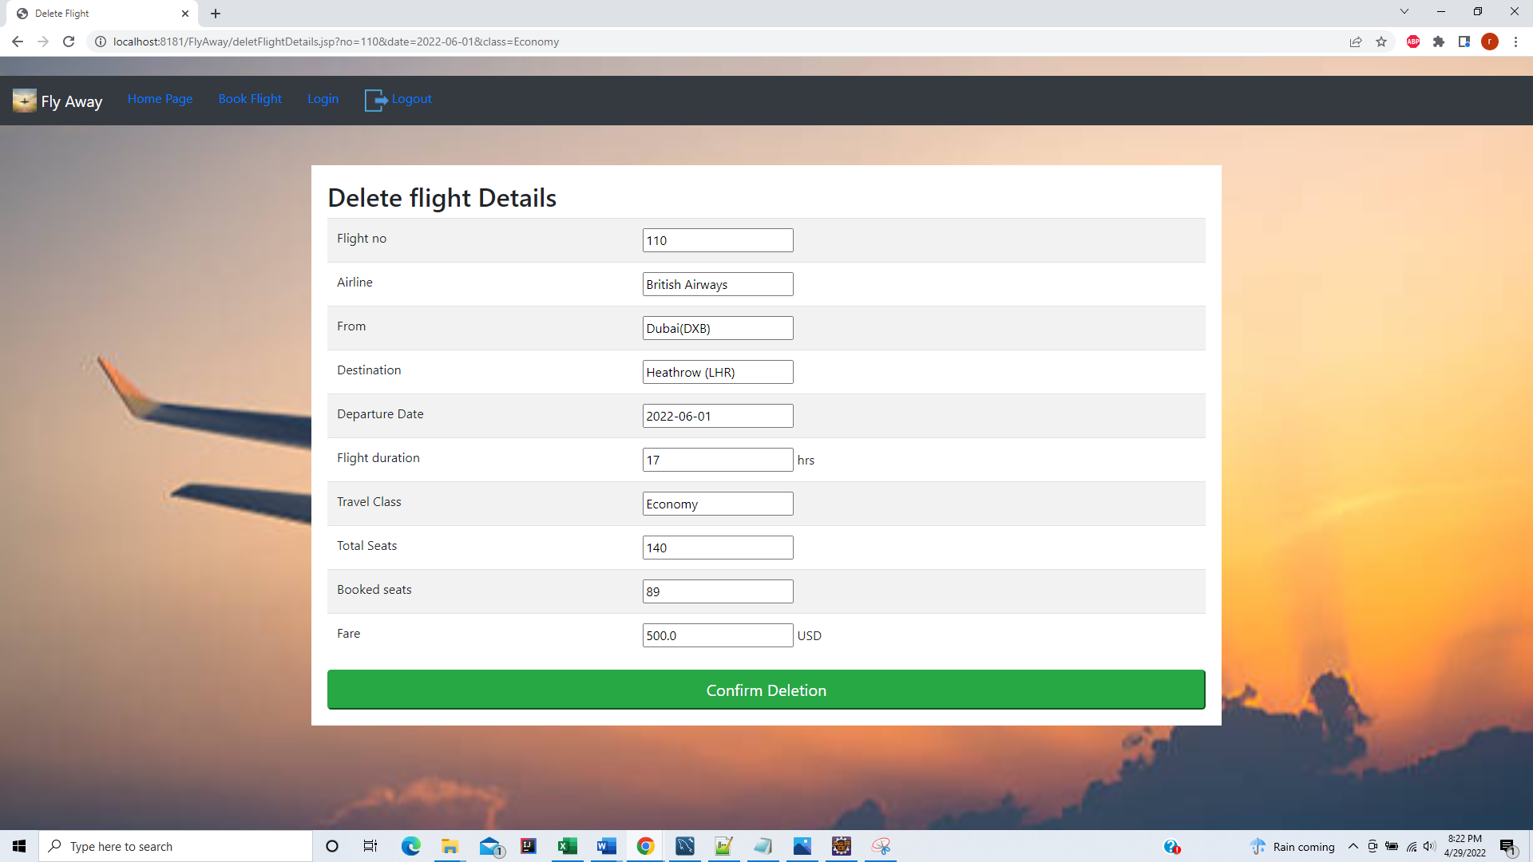

Before deletion 110 flightNo

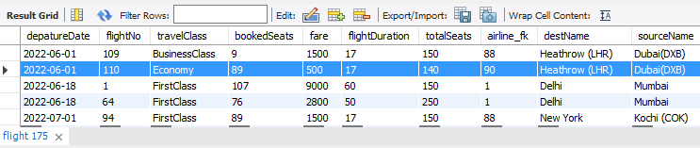

After deletion

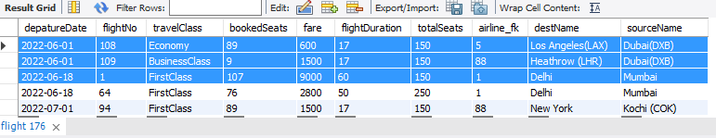

User has two roles – Customer /Admin below database entries

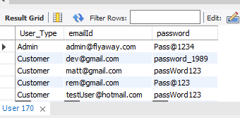

Admin or Customer Change Password Page

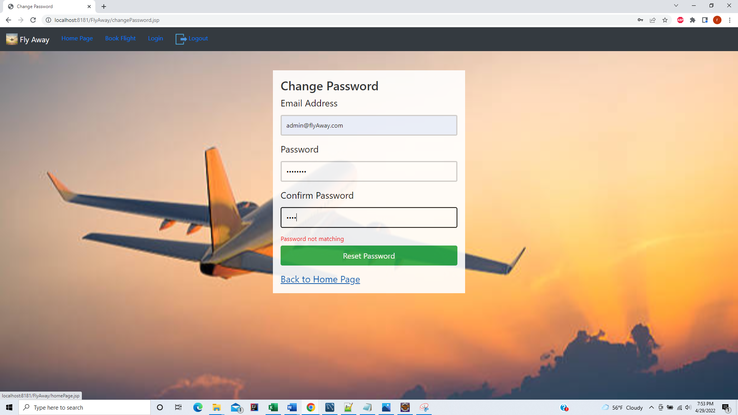

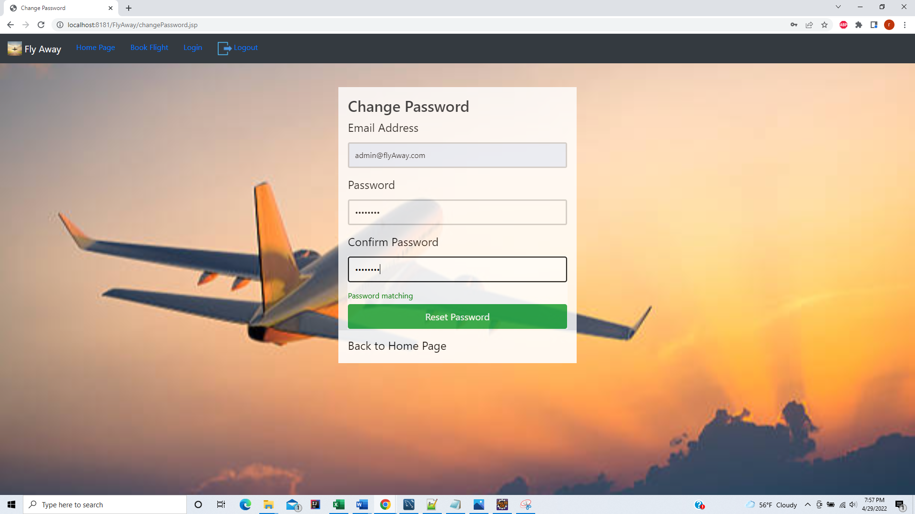

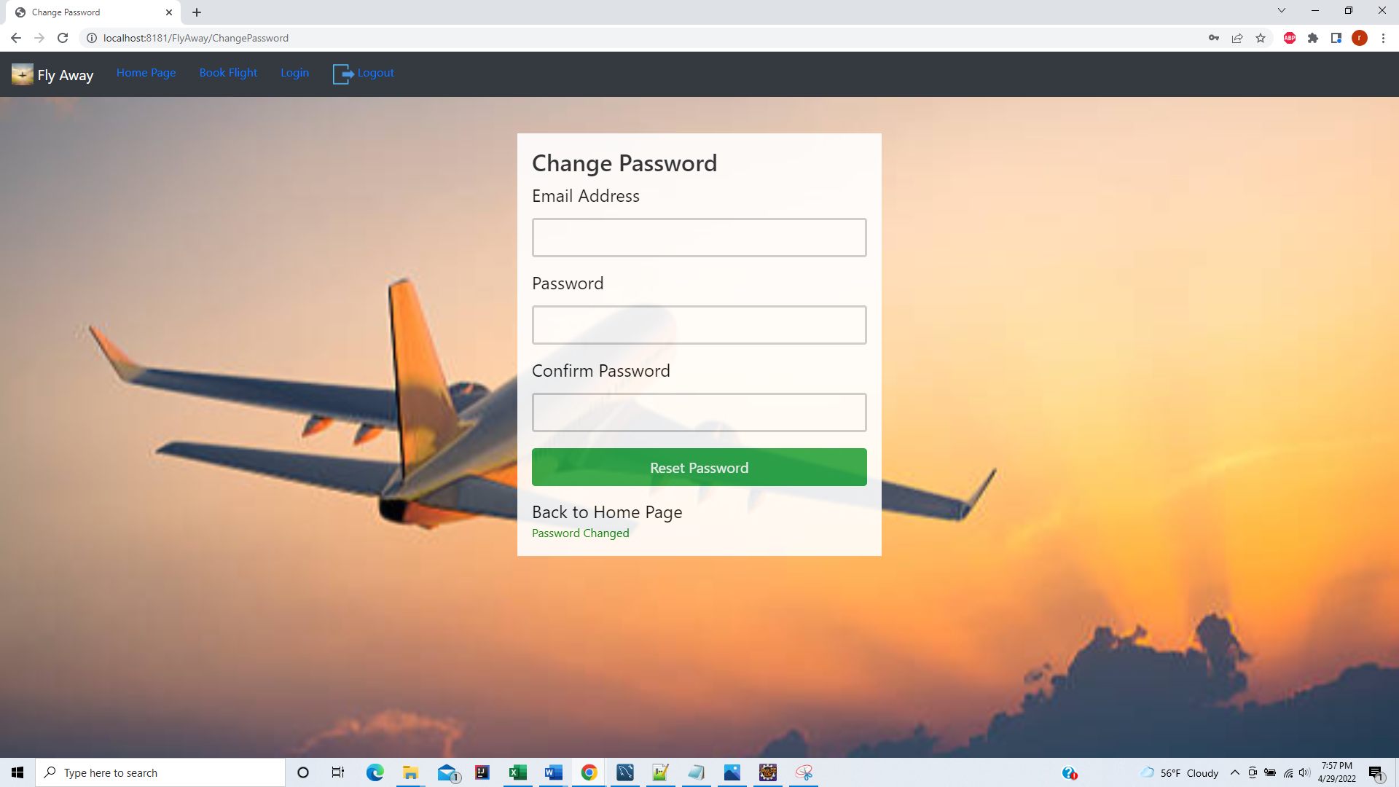

Password Reset in table

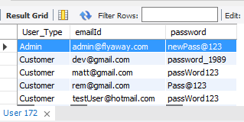

New Customer Sign up form

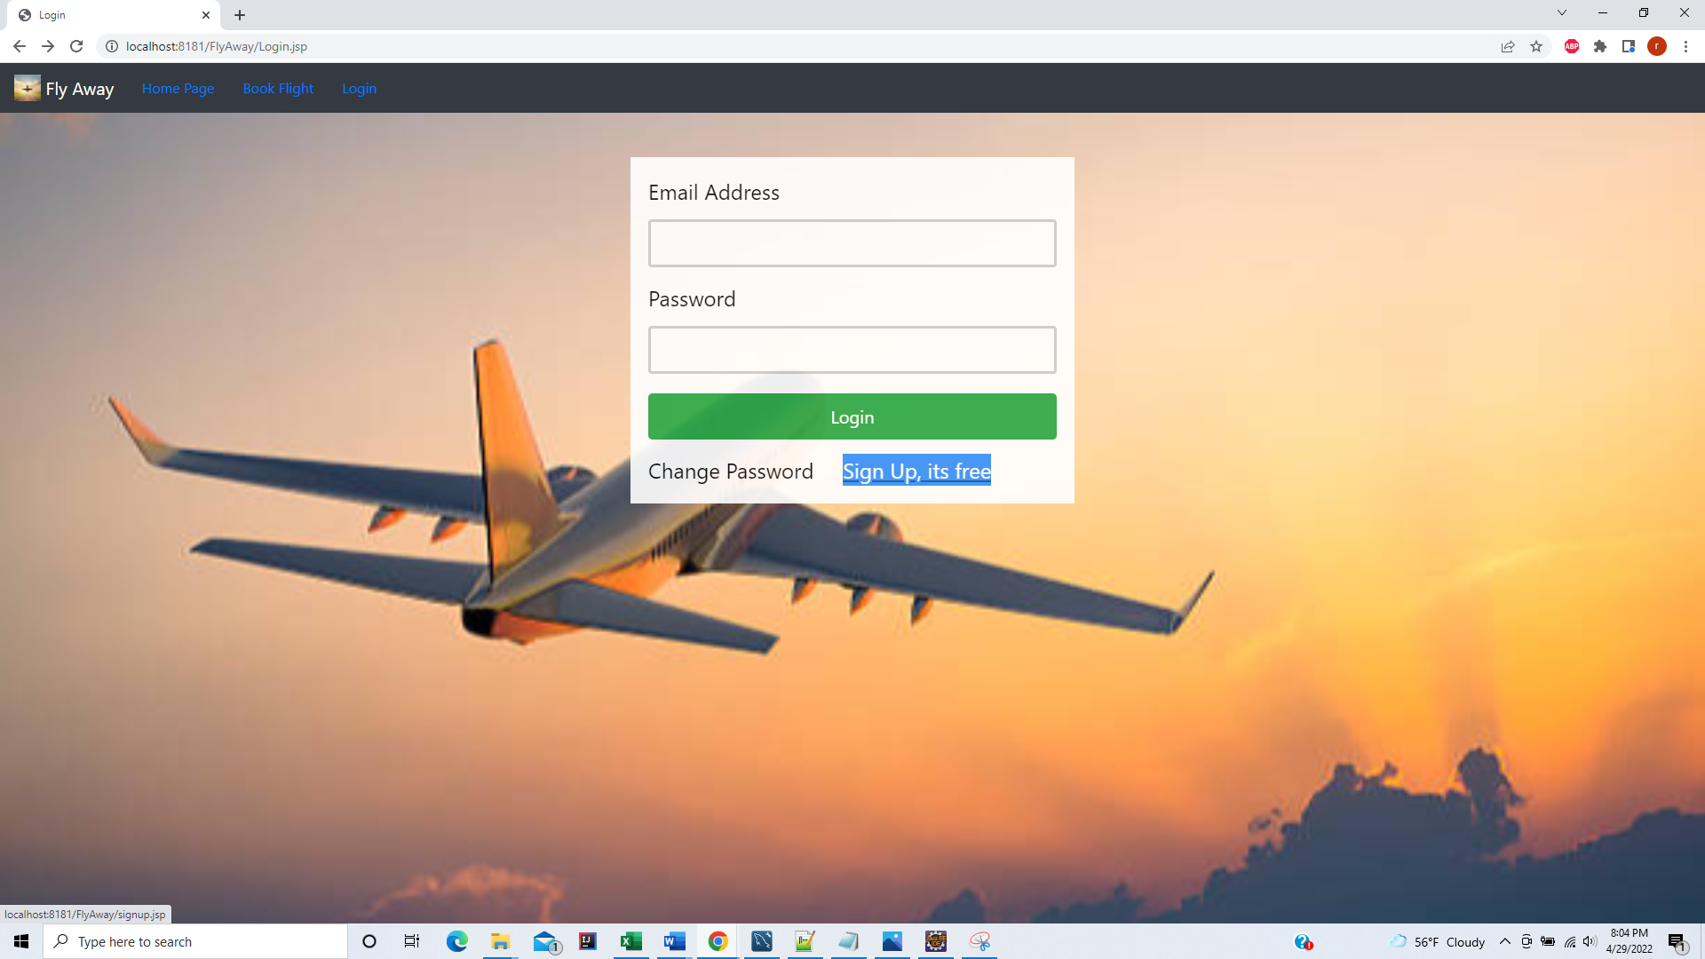

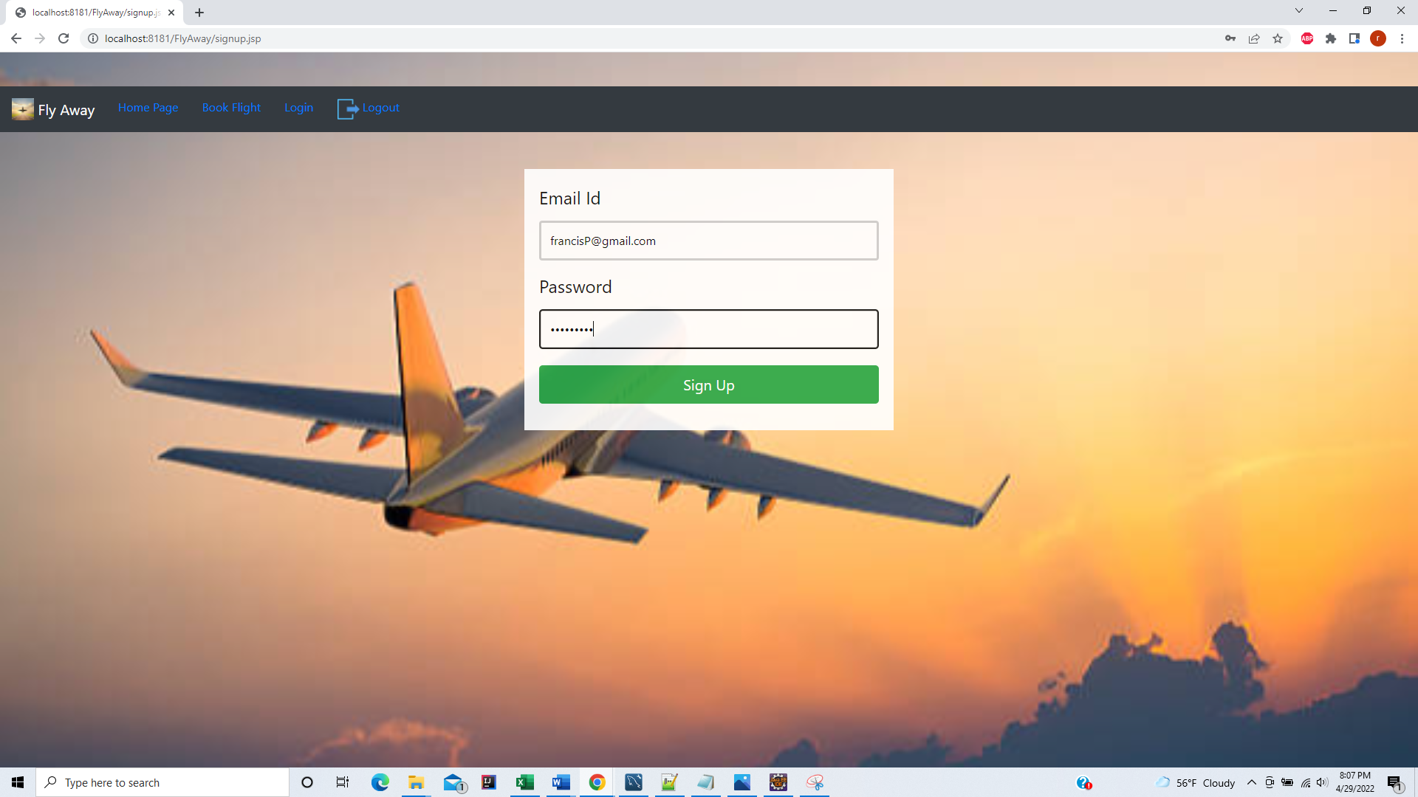

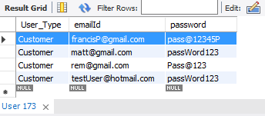

Email Id and Password validation

